TECHNICAL PROJECT REPORT

# Title of Invention / Project: Light emitting chess board

# Team Members / Inventors:

|  |  |  |  |  |  |
| --- | --- | --- | --- | --- | --- |
| **S. No.** | **Name** | **Department** | **Designation** | **Mobile** | **E-Mail** |
| 1. | Abhishek Sharma | ECE | Student | 7006857915 | abshek1726@gmail.com |
| 2. | Aviral Srivastava | ECE | Student | 9670489513 | aviralsrivastava746@gmail.com |
| 3. | Pankaj Saha | ECE | Student | 7407351957 | 123pankajsaha@gmail.com |
| 4. | Khushal Thakur | ECE | Mentor | 9646030764 | khushal.thakur@cumail.in |
| 5. | Anshul Sharma | ECE | Mentor | 9478697475 | anshulsharma.ece@cumail.in |
| 6. | Kiran Jot Singh | ECE | Mentor | 9463909689 | kiranjotsingh.ece@cumal.in |
| 7. | Divneet Singh Kapoor | ECE | Mentor | 9878422653 | divneet.ece@cumail.in |

Section – 1 (IPR Related)

# Brief Abstract:

Our project basically works on the principle of light emitting device.

we have used an led in our project which provides the source of light during the gameplay.

Generally we can play chess comfortably at low light.

It will glow as per the movements of the pieces of the chess.

Yes our project can be modified to greater extent.

We can use PCB boards instead of Bread Board, as to make it more compact,

because we use breadboard for temporary connection.

Soldiering of wire will make the connection better, instead of using jumper wires.

# Novel/Additional modifications that you can propose to improve upon drawbacks

* Soldering of wire instead of using jumper wires.
* Using of pcb board instead of bread board.
* Using of IR sensor instead of using LDR.

# Advantages

* It will glow when their will be the movement of chess pieces.
* The circuit will be simple and not be complicated.

Section – 2 (Real Project)

# Materials

Leds, ldr, wires, npn transistors, breadboard, resistors(100k and 220 ohms), wooden frame, acrylic sheet, and cardboard.

1. LED 64 2 64*2= 128 128
2. Breadboard 4 50 50*4= 200 200
3. Jumper wires 350 2 350*2= 700 700
4. N-P-N Transistor 64 4 64*4= 256 256
5. Resistor(220k) 64 3 64*3= 192 192
6. Resistor(100k) 64 2 64*2= 128 128
7. LDR 64 7 64*7= 448 448
8. Wooden Box 1 600 1*600= 600 600
9. Acrylic Sheet 1 80 1*80= 80 80
10. Total 2732

# Circuit Diagram

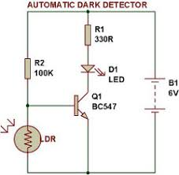

# Steps of Circuit Completion

1. 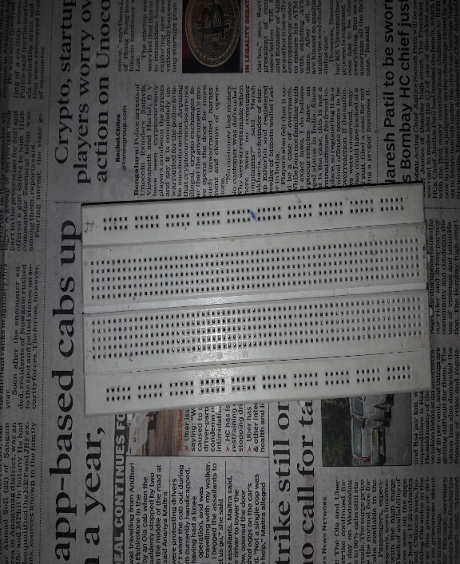
2. 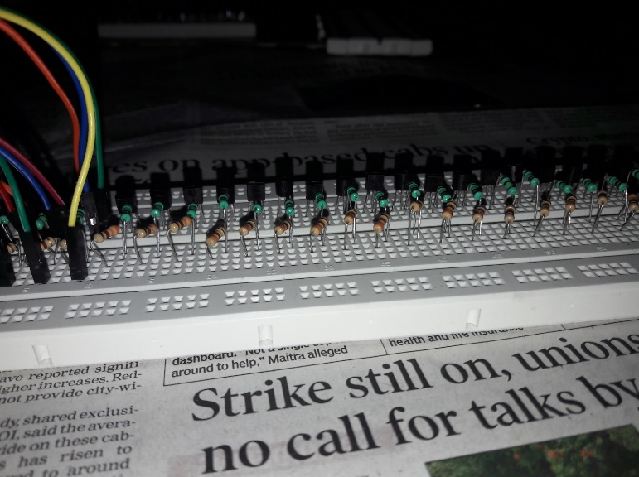

(3)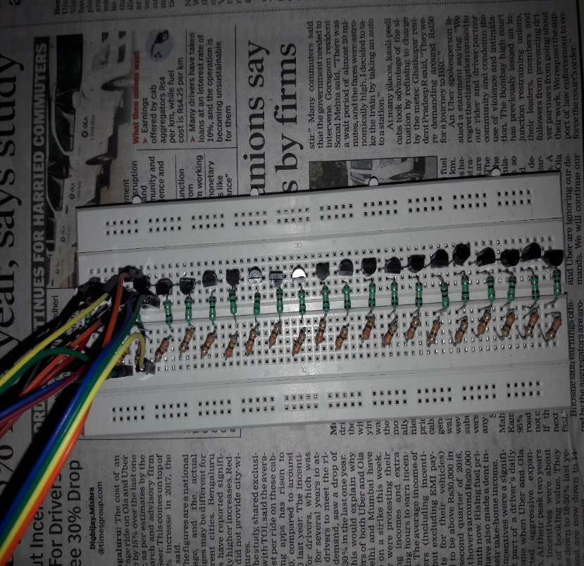 (4)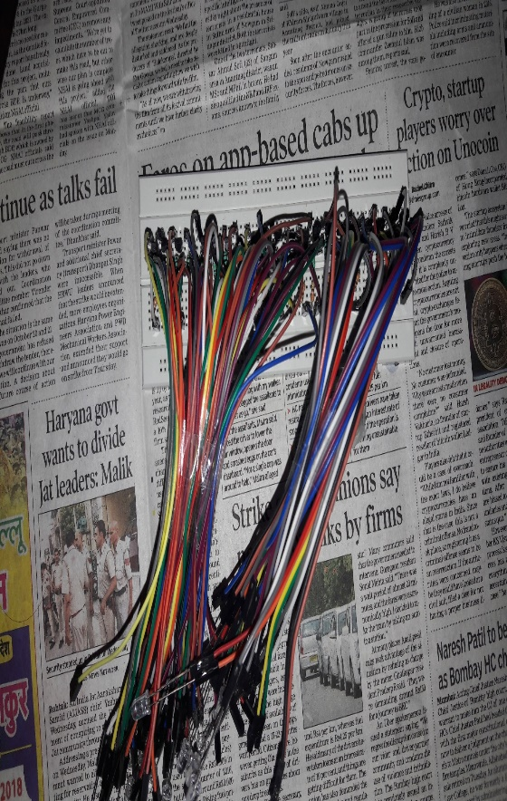

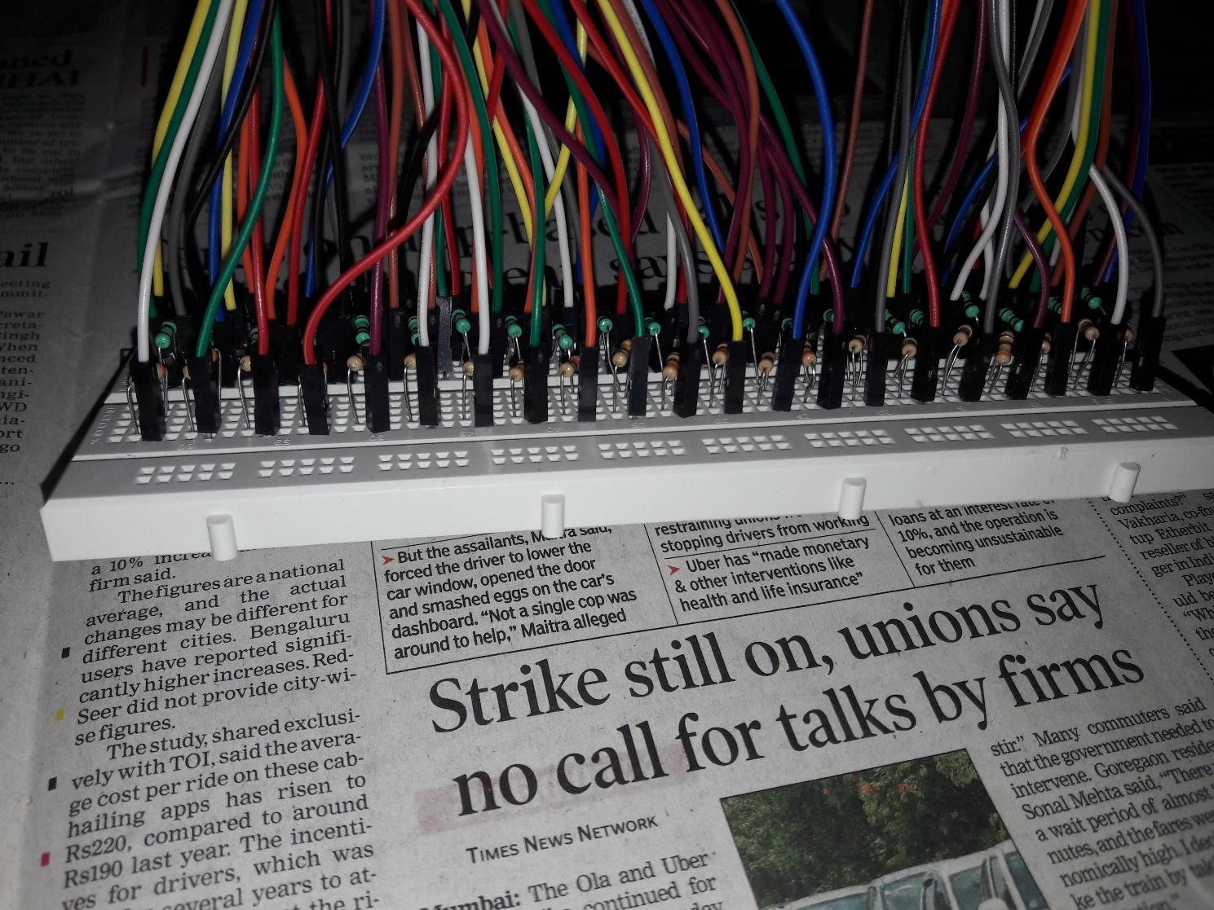

(5)

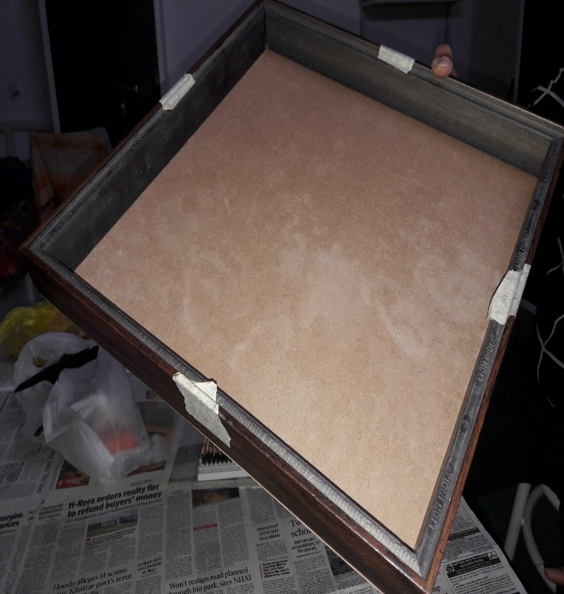`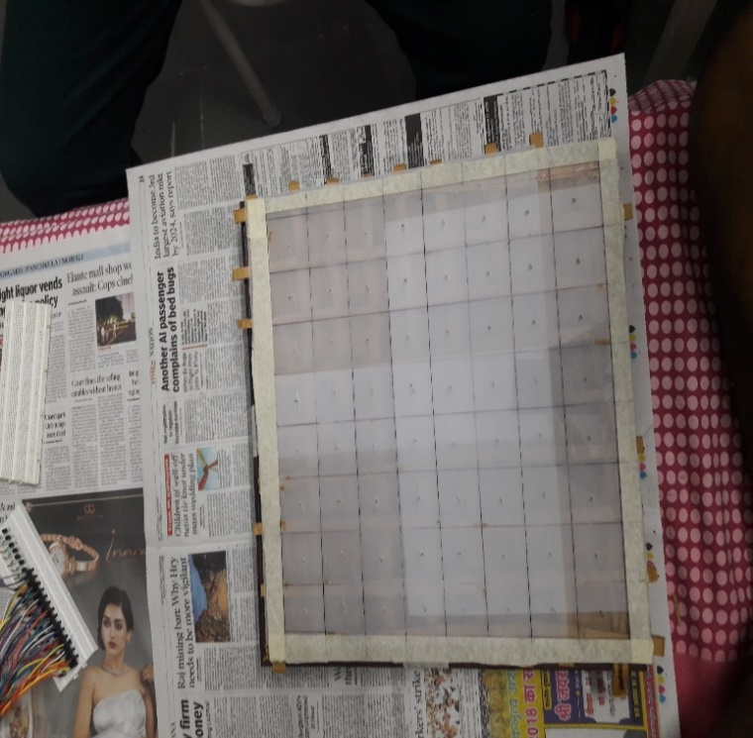

(6) (7)

# Program Code

https://github.com/aviral0308/Glowing-Chess